March 27, 2008

Edward Adelson
Associate Executive Dean
Colleges of the Arts and Sciences
114 University Hall
230 N Oval Mall
CAMPUS

Dear Ed,

The College of the Arts Curriculum Committee has reviewed and voted unanimously to support the Department of Art Education’s proposal to revise the requirements for the undergraduate Bachelor of Art Education (a tagged degree approved by OAA in May of 1990). We discussed the proposal with Professor Kevin Tavin, Chair of Undergraduate Studies in the Department of Art Education, during our ARTS CC deliberations on Monday, March 3, 2008, and we were pleased to unanimously support the Department of Art Education’s changes to the B.A.E. requirements.

The proposal was vetted and supported by the full faculty in the department, designed in close consultation with the Arts Advising Staff, and the Department of Art. As noted in the Department of Art’s cover letter, the Department of Art Undergraduate Studies Chair and the Department of Art Education Undergraduate Studies Chair met several times to streamline the two proposals so that their students may flow seamlessly from the BFA in Art into the senior year of the BAE in Art Education. This collaborative approach to educating the students toward a BAE in Art Education will facilitate students’ contact with the Department of Art Education from the first moment they step onto campus rather than the past experience of meeting with the department later in sophomore or junior year. The revisions are reflective of the field and new Undergraduate Studies leadership in both departments and the suggestions of the accrediting body of the National Association of Schools of Art and Design (NASAD).

The BAE tagged degree is currently 191 credit hours, with 71 in the General Education Curriculum and 120 in the major program. These will reduce to a total of 181, making the BAE the first tagged degree in the College of the Arts to reduce to 181. The 181 credit hours will be dispersed with 65 in the General Education Curriculum and 115 in the major program. The primary changes are described below:

- GEC reflects the revised GEC with the current/new categories and reduces the original 70 hour requirements to 65 by reducing the Social Science requirement from 15 to 10 to reflect the newly revised GEC requirements for this category. This is a total reduction of 5 credit hours in the GEC requirements.

- The department also added Art Education 255 and Art Education 367.03 as options for fulfilling the GEC requirements.

- The major requirements are reduced from 120 to 115: (a) retiring Art Education 631 (3 cr. hrs.) and instead, spreading the content of assessment across the core curriculum in art education, and (b) reducing Art Education 640, from 5 cr. hrs. to 3 cr. hrs., reflecting the state of the field and its progression beyond the Getty report in the 1980s. This is a total reduction of 5 credit hours in the major requirements.

- Additional revisions to the major program include allowing students to select their own electives in the Department of Art rather than prescribing “elective” course work. This will allow students to gain depth in an area and pursue interests in a particular art discipline.

- Change of title of Art Education 601 reflecting the change in course content as it reflects the field of art education.

- The changes will take place in Autumn 2008 for entering senior students in the program. The department foresees no difficulty with advising as the students enter the Department of Art Education as seniors in order to fulfill the final major requirements of the BAE and begin the licensure process. Art Education will retain 067 for its majors and 849 for Pre-Art Ed.

We thank you in advance for moving this proposal through the next appropriate steps, and look forward to its ultimate approval and implementation for fall of 2008. If you have questions about the proposal please feel free to contact me at 292-5171 or through email, mockabee.1415.

Thank you,
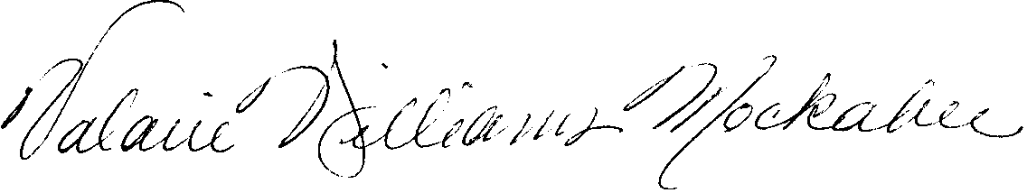
Valarie Williams Mockabee
Associate Dean, College of the Arts

cc: Kevin Tavin, Undergraduate Chair, Department of Art Education
ARTS CC

